
GLOBAL ACADEMY OF TECHNOLOGY
( A n A u t o n o m o u s I n s t i t u t e , a f f i l i a t e d t o V T U , B e l a g a v i )
A d i t y a L a y o u t , R a j a r a j e s h w a r i N a g a r , B e n g a l u r u , K a r n a t a k a 5 6 0 0 9 8

COURSE PROJECT PROPOSAL CSE23602 – MACHINE LEARNING
PROJECT  TITLE | Predictive Market Demand Analysis in E-Commerce Using Linear Regression and Support Vector Machine (SVM)
DOMAIN OR FIELD | Finance and Machine Learning (E-Commerce Analytics)
TEAM MEMBERS | 1GA23CS135 | 1GA23CS151 |  | 1GA23CS191
 | RANNA | SHAKTHI VEL K |  | VEERU GOWDA G R
SUBMISSION DATE | 27-04-2026 |  | APPROVED  BY:- |  | Faculty In charge | Signature
 |  |  |  |  | Dr. MANJUNATH CR

I. INTRODUCTION TO DOMAIN AND PROBLEM IDENTIFIED | The domain of Finance and Machine Learning in E-Commerce Analytics focuses on analyzing large-scale transactional and behavioral data to predict market demand, optimize inventory, and improve business decisions. With the rapid growth of online retail platforms, demand forecasting has become a critical component in financial planning and supply chain optimization. Studies such as [1] highlight that traditional statistical models are insufficient in handling dynamic and complex market environments. Research in [2] and [3] emphasizes the use of machine learning techniques to improve prediction accuracy by capturing non-linear relationships in data. Furthermore, modern approaches incorporate customer behavior and online reviews to enhance forecasting performance, as discussed in [4]. These advancements demonstrate the importance of integrating financial analytics with machine learning to handle uncertainties in e-commerce demand. However, challenges such as data variability, seasonality, and large-scale datasets make accurate demand prediction difficult, leading to inefficiencies in inventory management and financial losses.  To address these challenges, machine learning models such as Linear Regression and Support Vector Machine (SVM) are widely used for demand forecasting. Linear Regression is a simple yet effective statistical method that models the relationship between dependent and independent variables, making it suitable for identifying linear trends in sales data. It is computationally efficient and easy to interpret, which makes it a strong baseline model. However, it struggles with complex and non-linear patterns. On the other hand, Support Vector Machine (SVM) is a powerful supervised learning algorithm capable of handling both linear and non-linear data using kernel functions. SVM works by finding an optimal hyperplane that minimizes prediction error while maximizing generalization. It performs well in high-dimensional datasets and is less prone to overfitting. Compared to Linear Regression, SVM provides better accuracy in capturing complex demand patterns, making it suitable for real-world e-commerce scenarios.  In this project, a hybrid approach combining Linear Regression and SVM is proposed to improve demand forecasting accuracy. Linear Regression will be used as a baseline model to capture overall trends, while SVM will handle non-linear relationships and complex patterns in the dataset. The model will be trained on historical e-commerce data, including sales and relevant features. Performance will be evaluated using metrics such as RMSE and MAE. This approach aims to provide accurate predictions, optimize inventory decisions, and support financial planning in e-commerce systems.
II. BACKGROUND | Demand forecasting in e-commerce has traditionally relied on statistical and time-series methods such as moving averages, exponential smoothing, and ARIMA models. These approaches use historical sales data to identify patterns such as trend and seasonality. While they are simple and easy to implement, they assume linear relationships and stable demand patterns, which are rarely observed in modern e-commerce environments. As online markets become more dynamic, influenced by promotions, customer preferences, and external factors, these traditional models fail to capture sudden fluctuations and complex dependencies. This leads to inaccurate predictions, resulting in overstocking, stockouts, and financial inefficiencies in supply chain management.  To overcome these limitations, machine learning techniques have been introduced in demand forecasting systems. Models such as Decision Trees, K-Nearest Neighbors, and Random Forests are used to capture non-linear relationships in large datasets. These models improve prediction accuracy by learning from multiple features, including pricing, seasonality, and customer behavior. However, they often require extensive feature engineering and large datasets for optimal performance. Additionally, some models like KNN suffer from high computational cost, while Decision Trees may lead to overfitting. Although ensemble methods such as Random Forest and Gradient Boosting improve performance, they increase model complexity and reduce interpretability, making them difficult to deploy in real-time financial systems.  Recent advancements have introduced deep learning models such as Artificial Neural Networks (ANN) and Long Short-Term Memory (LSTM) networks for demand forecasting. These models are capable of capturing temporal dependencies and complex patterns in sequential data. LSTM, in particular, is effective in handling time-series data with long-term dependencies. However, deep learning models require large amounts of data, high computational resources, and longer training time. They are also difficult to interpret, which is a significant drawback in financial domains where transparency and explainability are important.  Hybrid models have also been proposed to combine the strengths of different approaches. For example, models integrating ARIMA with machine learning algorithms or combining clustering with regression techniques have shown improved performance. These systems aim to capture both linear and non-linear patterns in the data. Despite their advantages, hybrid models often involve complex architectures and parameter tuning, making them challenging to implement and maintain.  Overall, existing systems have made significant progress in demand forecasting, but gaps remain in achieving a balance between accuracy, efficiency, and interpretability. There is a need for models that can handle both linear and non-linear patterns while maintaining simplicity and scalability.
III. OBJECTIVES | - To analyze and understand existing demand forecasting systems in e-commerce using traditional statistical methods and machine learning techniques, identifying their strengths, limitations, and gaps in handling dynamic and non-linear market behavior.  - To design and implement a demand forecasting model using Linear Regression and Support Vector Machine (SVM) that improves prediction accuracy by capturing both linear and non-linear patterns in e-commerce data.
IV. METHODOLOGY | The proposed system aims to predict market demand in the e-commerce domain using machine learning techniques. The study utilizes a synthetic Indian e-commerce dataset spanning 36 months, containing 30,600 records and 16 features such as order_date, zone, category,brand_type,customer_gender,customer_age,base_price,discount_percent,final_price,units_sold,revenue,sales_event,competition_intensity,andinventory_pressure.The dataset is assumed to have no missing values.  In the proposed approach, data preprocessing will be performed by encoding categorical variables such as zone, category, brand_type, and sales_event using One-Hot Encoding. Numerical features including base_price, discount_percent, final_price, and customer_age will be normalized to ensure uniform scaling. Relevant features influencing demand will be selected for model training.  The dataset will be split into training and testing sets in an 80:20 ratio. Two regression models, Linear Regression and Support Vector Regression (SVR), will be implemented. Linear Regression will model the linear relationship between input features and the target variable, while SVR with an RBF kernel will capture non-linear patterns. Key parameters such as kernel type, regularization parameter (C), and epsilon (ε) will be tuned.  Model performance will be evaluated using Mean Absolute Error (MAE), Mean Squared Error (MSE), and R² score. The system is expected to predict revenue or units_sold based on pricing and market conditions.  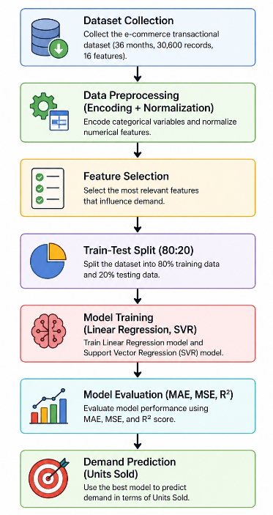  Figure 1: Proposed System Flow Diagram
V. REFERENCE | [1] Review and Analysis of AI Methods for Demand Forecasting in Supply Chain Management (2021)  [2] Machine Learning in Demand Forecasting (2020)  [3] Demand Forecasting Based on Machine Learning Algorithms on Customer Information (2021)  [4] Machine Learning Implementation for Demand Forecasting in Supply Chain Management (2022)  [5] Machine Learning and Deep Learning Models for Demand Forecasting in Supply Chain Management: A Critical Review (2024)  [6] Demand Forecasting for E-Commerce Platforms (2022)  [7] SmartMart – An Automated Shopping Mart with Blink and Facial Recognition for Payment (2023)  [8] Machine Learning for Demand Forecasting in Manufacturing (2023)  [9] Multivariate SVR Demand Forecasting for Beauty Products Based on Online Reviews (2023)  [10] A Hybrid Machine Learning Model for Demand Forecasting: Combination of K-Means, Elastic-Net, and Gaussian Process Regression (2023)

